SanFranciscoSentinel.com
News Coverage That Matters
A Thomas-Murphy Publication
230 Eddy Street Suite 211 San Francisco, CA 94102-6514
Voice: (415) 846-2475 Email: SanFranciscoSentinel@yahoo.com

July 31, 2006

To: MIKE DENNY

Re: SENTINEL ADVERTISING

Dear Mike:

I’m forwarding the Sentinel advertising package for November candidates or ballot measures you might know who could benefit.

Unique benefits include:

* SanFranciscoSentinel.com is the news leader among San Francisco’s political class, those who make things happen. It long ago surpassed Usual Suspects as the first place to turn for San Francisco political news.

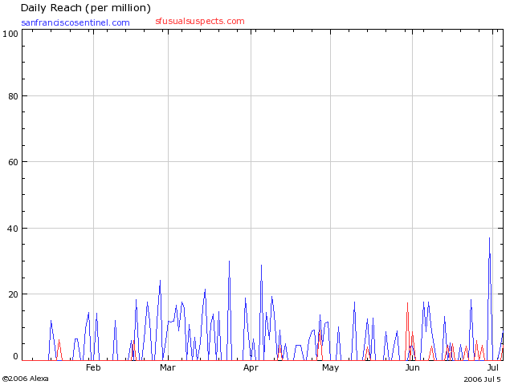

* Sentinel online advertising empowers your campaign to instantly frame issues and instantly shape developing public onion. Ad message and images may be changed immediately and as often as you wish from your office.

* Your campaign message is carried in Sentinel mass email notification of latest Sentinel content – sent throughout each day as news warrants. Our mailing list includes elected and appointed officials and staff, more than 75 local news media reporters, political and community organizations, and political activists.

* Proven reliable, the Sentinel is in its sixth year of publishing daily, with continued general readership expansion. Google now ranks Sentinel importance at a ‘6’ rating – compared to a ‘9’ rating for CNN.com.

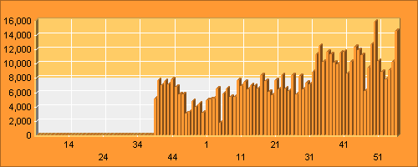

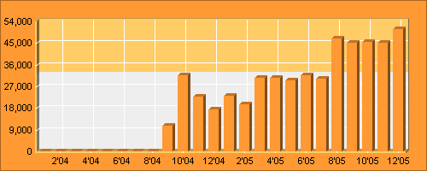

Sentinel growth statistics independently compiled by OneStat.com

PRICING

Prices quoted are for length of campaign with publication beginning August 1, 2006, through November 7, 2006, election.

125 pixels x 600 pixels

$2,000

125 pixels x 240 pixels

$1,500

125 pixels x 125 pixels

$750

Photography for campaign materials also is available through Sentinel Editor-In-Chief Luke Thomas at licensing fees dependent on use. Contact Thomas for price quote at 415-290-1802 or by email Sentinel@adlestrop.com

Thank you for your consideration. I hope for the opportunity to satisfy any questions.
“The Sentinel has established itself as a resource for news and information gathering relating to the world of San Francisco politics. Its coverage of the city's political landscape allows even the most discerning reader a rare opportunity to see the human side of politics.”
-- San Francisco Mayor Gavin Newsom
"Pat Murphy is one of the hardest working journalists in San Francisco. He's made scooping the big guys into an art form, and the Sentinel is a must-read for people who want the real, in-depth skinny on the San Francisco political scene."
-- Aaron Peskin, President, San Francisco Board of Supervisors

Sincerely,

Pat Murphy
Sentinel Founder and Editor Emeritus

