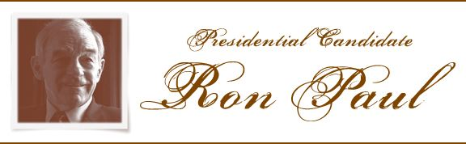
invites you to San Francisco for 2 exclusive events!
September 13th, 2007
Breakfast with Ron Paul
Select $500 Donor
The Palace Hotel
Presidential Suite
9 AM to 11 AM
2 New Montgomery Street
San Francisco, California 94105
Lunch with Ron Paul
Select $500 Donor
Palio D’Asti Restaurant
12 PM to 2 PM
640 Sacramento Street
San Francisco, California 94111
Donate to http://www.ronpaul2008.com/donate (both credit card and checks)
Breakfast Code: 9131 • Lunch Code: 9132
RSVP to ronpaulrsvp@yahoo.com
Indicating name, number of guests and breakfast or lunch.

